ASSIGNMENT – 02

STUDENT ADMISSION ENQUIRY FORM
1. AIM
To design and develop a functional Student Admission Enquiry Management application using Zoho Creator that demonstrates the correct usage of all thirteen Basic Fields available in the Form Builder while solving the institutional requirement of capturing structured student admission enquiries.
2. OBJECTIVE
The objective of this experiment is to create a digital admission enquiry form using Zoho Creator. The application captures the personal details, contact information, academic preferences, counselling availability, and consent of prospective students in a structured and validated manner.
The application also demonstrates the use of forms, reports, field-level validation, and workflow automation in a low-code development environment.

3. PROBLEM STATEMENT
The Admissions Office of a college receives student enquiries through phone calls, walk-ins, and emails. This may result in inconsistent and incomplete records.
To overcome this problem, a low-code application is developed using Zoho Creator. The application allows a prospective student or front-office staff member to submit an admission enquiry through a single online form.
The form captures personal identity, contact details, academic interests, preferred counselling time, and consent using all thirteen Basic Field types provided by the Zoho Creator Form Builder.

6. BASIC FIELDS USED
The application uses all thirteen Basic Fields specified in the assignment.
S.No | Basic Field | Form Field Name | Purpose
1 | Name | Student_Name | Captures the full name of the applicant
2 | Email | Email_Address | Captures the applicant's email address
3 | Address | Residential_Address | Captures the applicant's residential address
4 | Phone | Contact_Number | Captures the applicant's mobile number
5 | Single Line | Guardian_Name | Captures the parent/guardian name
6 | Multi Line | Additional_Remarks | Captures additional remarks
7 | Number | Class_XII_Percentage | Captures Class XII percentage
8 | Date | Date_Of_Birth | Captures the applicant's date of birth
9 | Time | Preferred_Counselling_Time | Captures preferred counselling time
10 | Drop Down | Preferred_Course | Allows selection of preferred course
11 | Radio | Gender | Captures the applicant's gender
12 | Multi Select | Areas_Of_Interest | Allows selection of multiple interest areas
13 | Checkbox | Terms_Agreement | Captures agreement to terms and privacy policy
These field mappings and their purposes follow the assignment specification.

7. FORM LAYOUT
The form was divided into four logical sections to organize the student information clearly.

Section A – Personal Details
The Personal Details section contains:
- Student Name
- Date of Birth
- Gender

Section B – Contact Details
The Contact Details section contains:
- Email Address
- Contact Number
- Residential Address

Section C – Guardian & Academic Details
The Guardian & Academic Details section contains:
- Guardian Name
- Class XII Percentage
- Preferred Course
- Areas of Interest

Section D – Scheduling & Consent
The Scheduling & Consent section contains:
- Preferred Counselling Time
- Additional Remarks
- Terms & Privacy Policy Agreement
This four-section arrangement follows the layout specified in the assignment.

8. PROCEDURE

Step 1: Creating the Zoho Creator Application
A new application was created in Zoho Creator using the Blank Application option.
The application was named:
Student Admission Enquiry Management
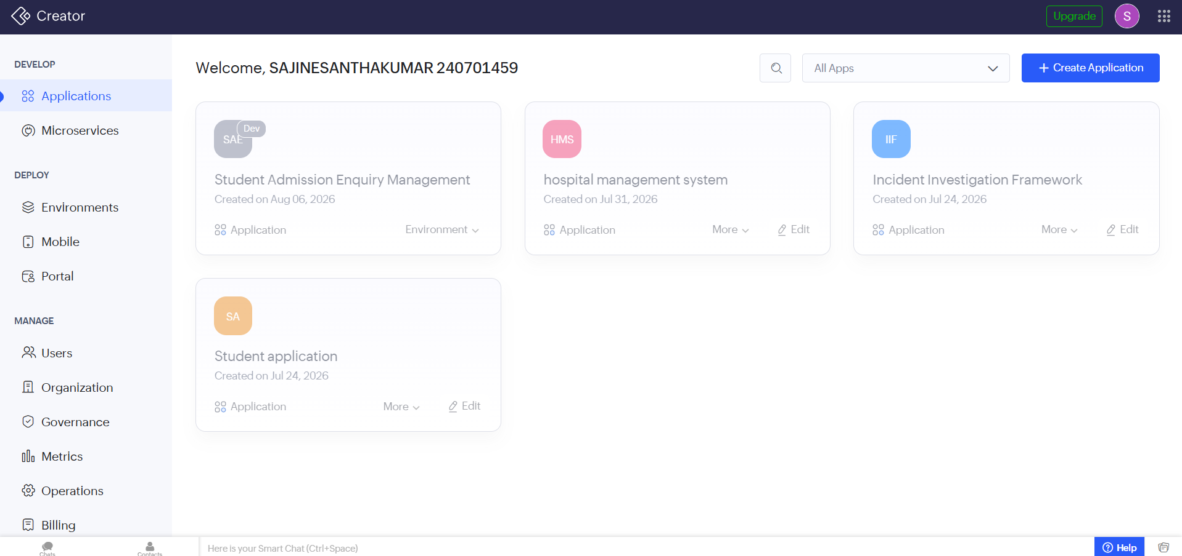

Step 2: Creating the Admission Enquiry Form
A new form was created inside the application with the name:
Admission_Enquiry_Form
The form was used to collect the personal, contact, academic, scheduling, and consent information of prospective students.
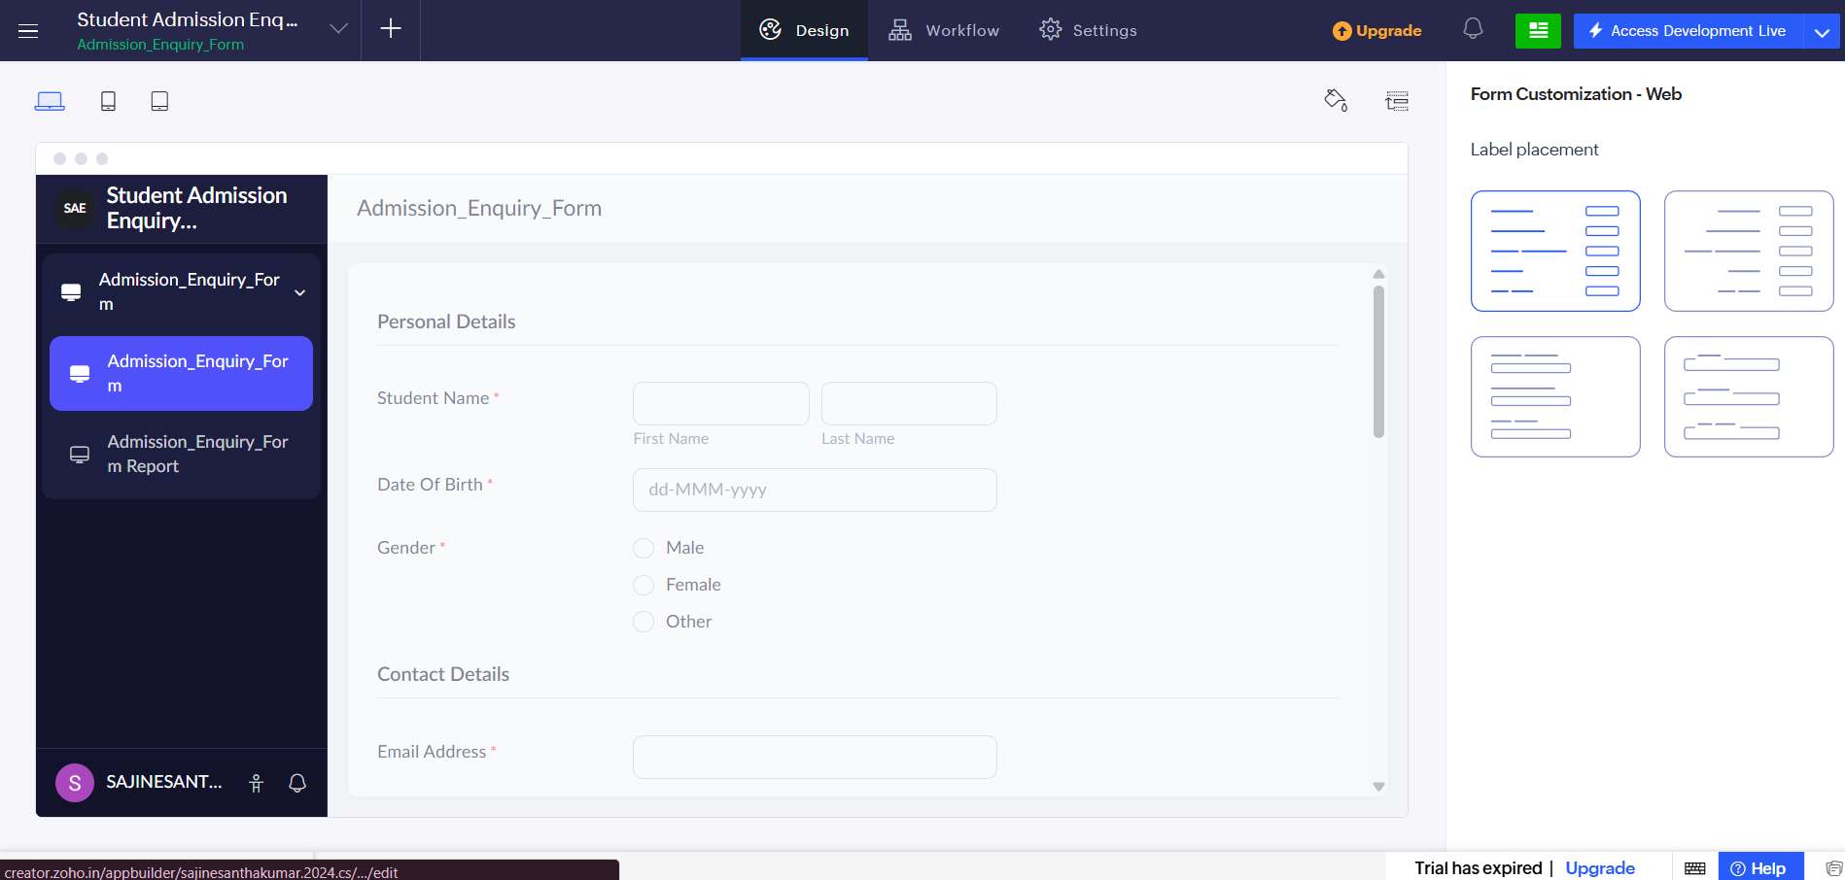

Step 3: Adding the Basic Fields
All thirteen Basic Fields specified in the assignment were added to the Admission Enquiry Form.
The fields were configured according to their respective purposes, such as capturing names, email addresses, phone numbers, academic marks, course preferences, areas of interest, and consent.
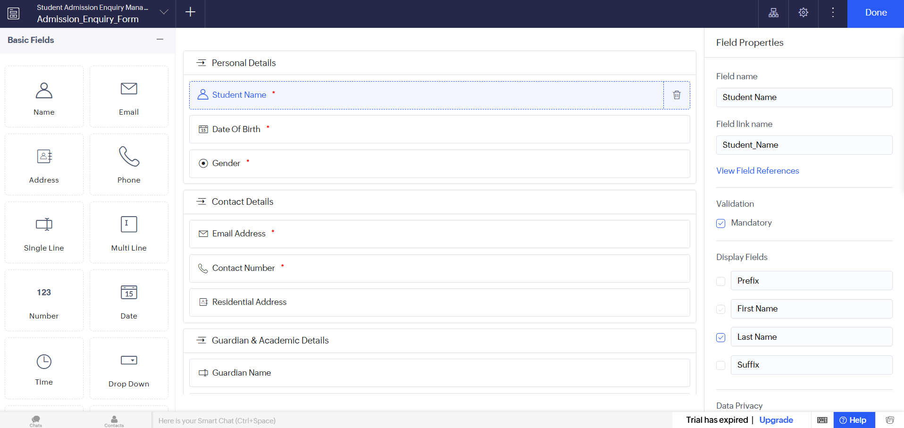Form Builder showing the Basic Fields

Step 4: Creating Form Sections
The form was organized into four sections:
- Personal Details
- Contact Details
- Guardian & Academic Details
- Scheduling & Consent
This arrangement improves the readability and usability of the form.

9. FIELD VALIDATION
The following validation rules were configured in the form.
Field | Validation
Student Name | Mandatory
Email Address | Mandatory and valid email format
Contact Number | Mandatory and Indian phone number format
Date of Birth | Mandatory and future dates are not allowed
Gender | Mandatory
Preferred Course | Mandatory
Class XII Percentage | Value restricted from 0 to 100
Terms Agreement | Mandatory; form cannot be submitted without agreement
The assignment specifically requires mandatory fields, email format validation, Indian phone format, percentage range validation, restriction of future dates, and mandatory terms agreement.

10. LIVE PREVIEW OF THE FORM
After completing the form configuration, the form was opened using the Live Preview option.
The Live Preview was used to verify the appearance, arrangement, field inputs, and overall functionality of the Admission Enquiry Form.

11. SUBMITTING SAMPLE RECORDS
Three sample student admission enquiries were submitted through the completed form.
Sample student records were entered with different personal, contact, academic, and course preference details.
The submitted records were automatically stored in the corresponding Zoho Creator report.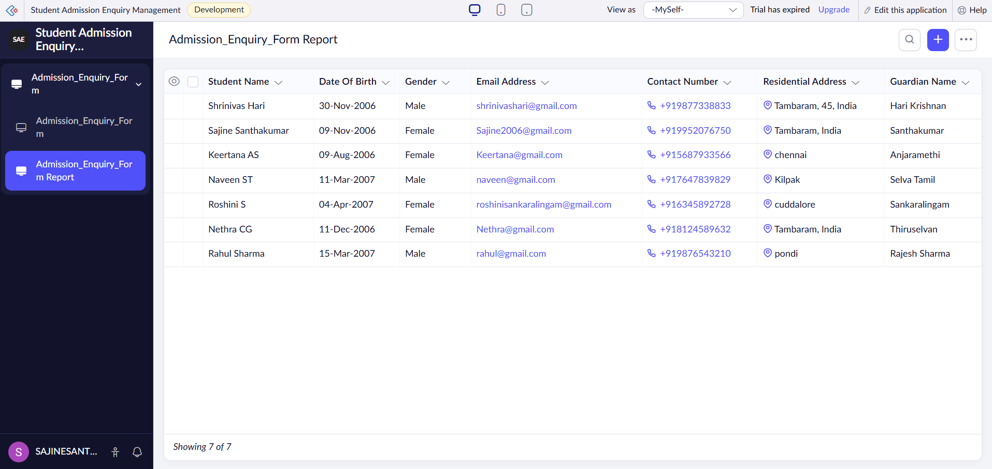

12. ADMISSION ENQUIRY REPORT
Zoho Creator automatically generated a report for the submitted form records.
The report was named:
Admission_Enquiry_Report
The report allows the Admission Cell to view, review, and filter the submitted admission enquiries.

13. WORKFLOW AUTOMATION
A workflow was created to automate the confirmation process after a successful form submission.
The workflow was named:
Admission Confirmation Email
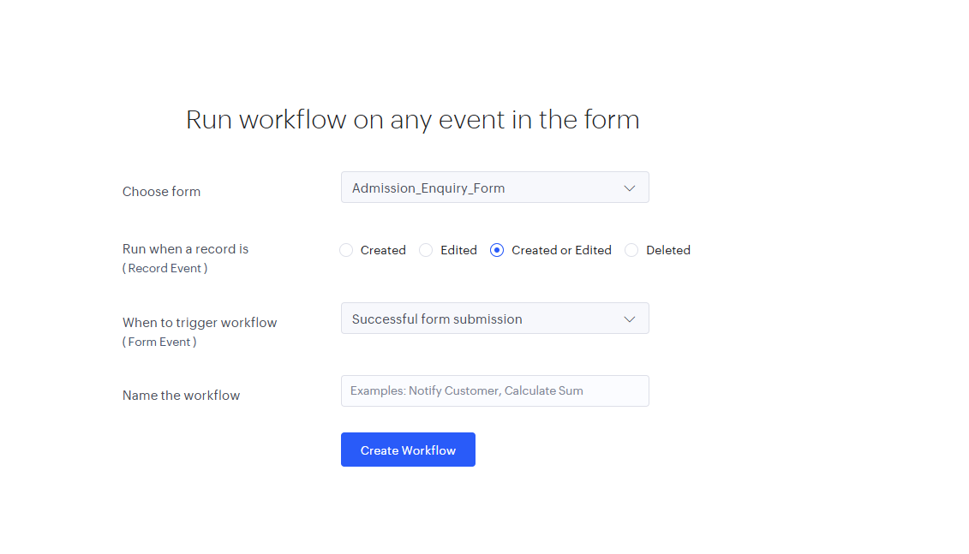
The workflow is triggered when a new record is successfully created through the Admission_Enquiry_Form.
The workflow sends a confirmation email to the email address provided by the student.
The workflow follows the sequence:
Form Submission → Successful Submission → Record Created → Confirmation Email
The assignment specifies that an automated confirmation email should be triggered using the Email field value after successful submission.
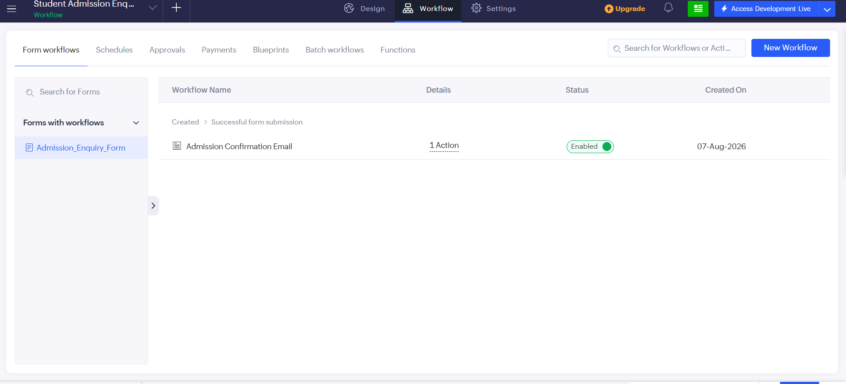

14. TESTING
The application was tested by submitting sample student admission enquiries.
The following conditions were verified:
- Mandatory fields cannot be left empty.
- Email addresses are validated using the email format.
- Contact number accepts the required phone format.
- Class XII percentage accepts values between 0 and 100.
- Future dates are not accepted for Date of Birth.
- Gender must be selected.
- Preferred Course must be selected.
- Terms and Privacy Policy agreement is required before submission.
- Successfully submitted records appear in the Admission_Enquiry_Report.
- The confirmation email workflow is triggered after successful submission.

15. WORKFLOW OF THE APPLICATION
The overall workflow of the application is:
Applicant opens the Admission Enquiry Form
↓
Applicant enters personal details
↓
Applicant enters contact details
↓
Applicant enters academic details
↓
Applicant selects counselling time
↓
Applicant agrees to Terms & Privacy Policy
↓
Submit Form
↓
Zoho Creator validates data
↓
Record is created
↓
Record appears in the Report
↓
Confirmation Email is sent
↓
Admission Cell reviews
and follows up with enquiry
This workflow is based on the workflow summary provided in the assignment.

16. RESULT
The Student Admission Enquiry Management application was successfully designed and developed using Zoho Creator.

